

**BLACK HOLE**

**Group Member:**

1. **Summiya saif ( 2212143)**
2. **Sheryar Ali ( 2212154)**

Table of Contents

Contents

Black hole 3

1.1 One black hole is not like the others 4

1.2 Peering through the darkness 4

One Star’s End is a Black Hole’s Beginning 5

Babies and Giants 6

Reference 8

# Black hole

According to general belief, gravitationally collapsing bodies will create black holes. These black holes will settle down to a stationary state. It is necessary for the stationary state of a rotating black hole to be axisymmetric if it is rotating.

A black hole is a point in space that has such high density it creates a deep gravitational sink. A black hole's gravity is so powerful that not even light can escape its tug. Spacecraft, stars, or planets that venture too close will be stretched and compressed like putty, a theoretical process known as spaghettification.

There are [four types of black holes](http://hubblesite.org/reference_desk/faq/answer.php.id=62&cat=exotic): *stellar, intermediate, supermassive, and miniature*. Black holes are most commonly formed by stellar death. In the end of a star's life, most of them will inflate, lose mass, and then cool down to form white dwarfs. Larger bodies, at least 10 to 20 times as massive as our own sun, are destined to become super-dense neutron stars or stellar-mass black holes.

A supernova is a massive explosion that occurs when enormous stars reach their final stages. When such a burst occurs, star matter is thrust out into space but the stellar core is left behind. Nuclear fusion balanced the inward pull of gravity from a star's own mass while it was alive by creating an outward push. When the star remnants of a supernova are no longer able to resist gravity, they collapse in on themselves.

Black holes are formed when mass collapses into an infinitely small point. Black holes have powerful gravitational pull because they pack so much mass - many times the mass of our sun - into such a small area. A galaxy as large as our own may contain thousands of stellar-mass black holes.

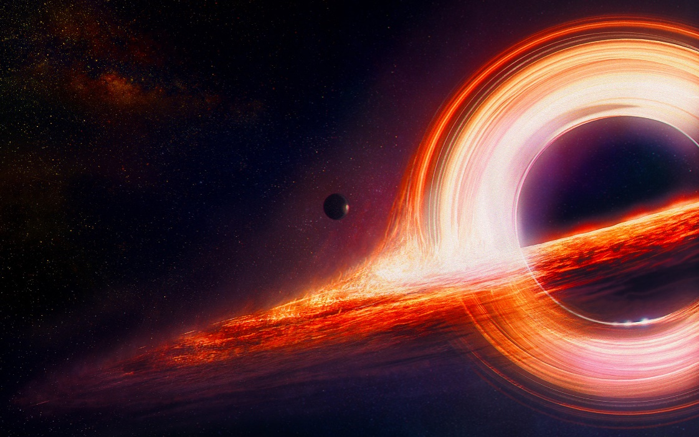

**Figure 1** shows the black hole.

1.1 One black hole is not like the others

Einstein's general theory of relativity foresees supermassive black holes, which could have masses equivalent to billions of suns and are thought to reside at the cores of most galaxies. Sagittarius A* (pronounced "ay star"), a supermassive black hole that is more than four million times as massive as our sun, is located at the core of the Milky Way.

The smallest black hole family members are currently only speculative. It's possible that these tiny dark vortices began to exist shortly after the big bang, or 13.7 billion years ago, and then quickly dissipated. Although there is currently some debate about the evidence, astronomers also believe that the cosmos contains a type of objects known as intermediate-mass black holes.

Black holes can develop during the course of their existence regardless of their initial size, swallowing gas and dust from any nearby objects. Theoretically, due to a dramatic rise in gravity as one falls towards the black hole, anything that exceeds the event horizon, the point at which escape is impossible, is doomed to spaghettification.

Astrophysicist Neil Degrasse Tyson once put it this way when he said that as you are being stretched, you are also being squeezed and being forced through space's fabric like toothpaste is forced through a tube.

Black holes, however, aren't quite "cosmic vacuum cleaners," as frequently portrayed in popular culture. To win this gravitational tug-of-war, objects must progressively get closer to one another. Our planetary family, for instance, would continue to circle unaffected even if our sun were abruptly replaced by a black hole of comparable mass. It would just be much less warm and lit.

1.2 Peering through the darkness

Astronomers cannot directly observe black holes like they do the myriad glittering cosmic objects in the sky because they swallow all light. But there are a few indicators that point to the existence of black holes.

One is that anything near a black hole feels the strong gravitational pull of the object. These erratic movements are used by astronomers to guess the presence of the nearby invisible monster. Alternatively, objects may orbit a black hole, and to find a likely candidate, astronomers might search for stars that appear to orbit nothing. In the early 2000s, astronomers finally recognised Sagittarius A* as a black hole in this manner.

Black holes often give away their locations since they are untidy eaters. Their powerful gravitational and magnetic forces superheat the infalling gas and dust, causing it to radiate radiation as they reach the nearby stars. A portion of this luminous debris swirls around the black hole in an accretion disc. Even material that first enters a black hole may not remain there permanently. Stardust falling into black holes can occasionally be ejected by powerful radiation-filled burps.

Black holes are invisible to telescopes that look for light, x-rays, or other types of electromagnetic radiation. But by observing how they affect neighbouring matter, we may deduce the existence of black holes and study them. A black hole will accrete matter, or pull it inward, if it passes through a cloud of interstellar matter, for instance. A normal star may experience a similar behaviour as it approaches a black hole. In this situation, when the star is being drawn toward the black hole, it may rip apart. The heated and accelerated attracting matter radiates x-rays into space as it accelerates and warms up. Recent findings provide some fascinating evidence that black holes have a profound impact on the areas around them. They release strong gamma ray bursts, devour neighbouring stars, and stimulate or hinder the birth of new stars depending on where they are located.

# One Star’s End is a Black Hole’s Beginning

The remnants of a big star that explodes in a supernova are what create the majority of black holes. Smaller stars decay into dense neutron stars, which are insufficiently massive to trap light. Theoretically, it may be demonstrated that no force can prevent a star from collapsing under the pull of gravity if the star's overall mass is high enough (about three times the mass of the Sun). However, an odd thing happens when the star disintegrates. Time on the star slows down in relation to time kept by observers far away when the star's surface approaches an idealised surface known as the "event horizon." Time stops when the star's surface hits the event horizon; as a result, the star becomes a frozen collapsing entity.

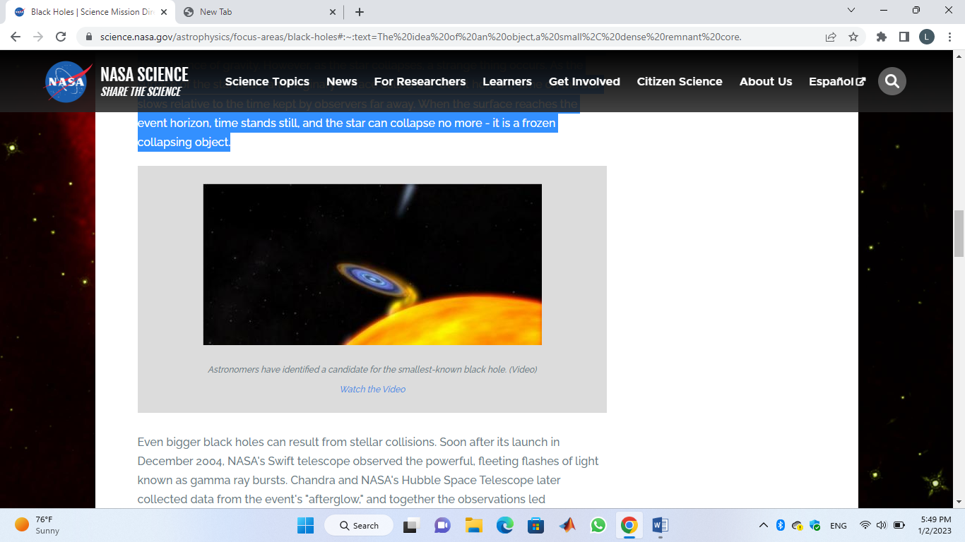

**Figure 2** shows the smallest black hole is discovered by an astronomer .

**Stellar collisions may produce much larger black holes. Swift, a telescope operated by NASA, started observing gamma ray bursts not long after its launch in December 2004. Astronomers deduced from observations made by Chandra and NASA's Hubble Space Telescope that the tremendous explosions can happen when a black hole and a neutron star meet, creating another black hole. Chandra and Hubble later acquired data from the event's "afterglow."**

# Babies and Giants

Black holes' basic formation mechanism is well understood, but their apparent existence on two dramatically different size scales has long been a conundrum in the field of black hole science. Numerous black holes that are the remains of huge stars can be found on one end of the spectrum. These "stellar mass" black holes, which are scattered throughout the Universe, are typically 10 to 24 times as massive as the Sun. When another star gets close enough for some of the material around it to be drawn into the black hole by its gravity and produce x-rays as a result, astronomers can see them. However, the majority of star black holes are very hard to find. However, based on the amount of stars big enough to create such black holes, researchers believe that the Milky Way alone contains between ten million and a billion such black holes.

The "supermassive" black holes, which are millions or even billions of times as massive as the Sun, are giants at the other end of the size range. Supermassive black holes, including the Milky Way, are thought to be at the heart of almost all major galaxies. By keeping an eye on their impacts on neighbouring stars and gas, astronomers can spot them.

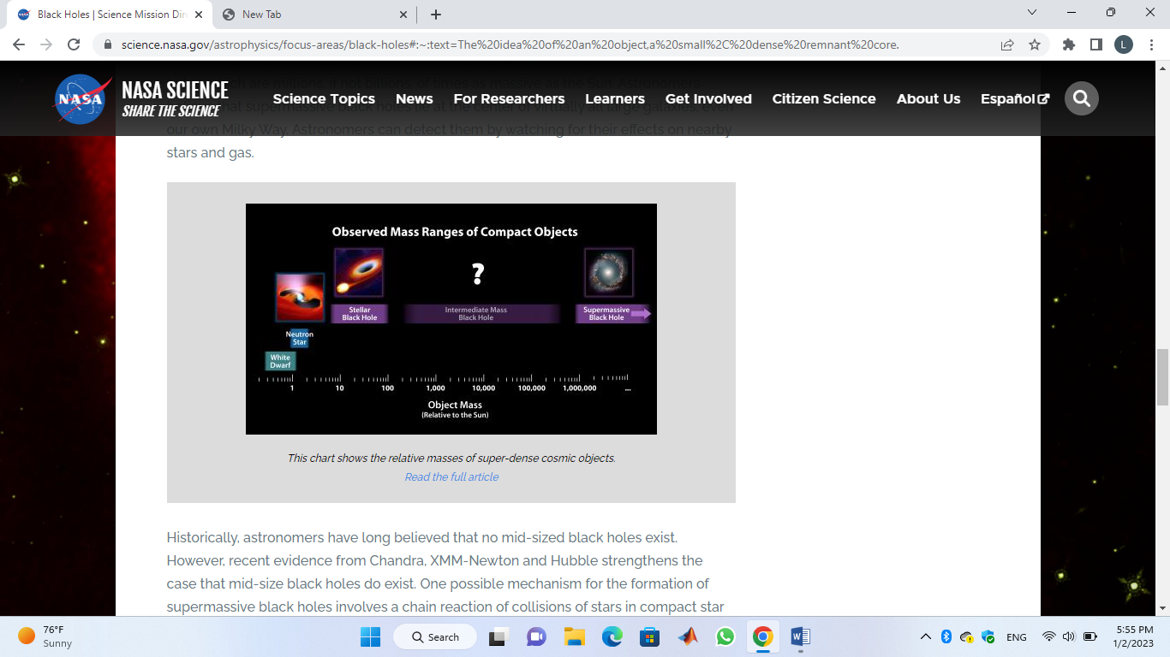

**Figure 3** shows the relative masses of super – dense cosmic objects

Astronomers have long held the view that there are no mid-sized black holes. But fresh proof from Chandra, XMM-Newton, and Hubble supports the existence of mid-size black holes. A chain reaction of star collisions in dense star clusters could lead to the accumulation of extremely massive stars, which would eventually collapse to generate intermediate-mass black holes as one potential route for the development of supermassive black holes. The intermediate-mass black holes subsequently combine to become a supermassive black hole when the star clusters fall into the galaxy's core.

**Table 1** represents recent discoveries of Blackholes

|  |  |
| --- | --- |
| **Date** | **Discovery** |
| October 13, 2022 | [Swift, Fermi Missions Detect Exceptional Cosmic Blast](https://www.nasa.gov/feature/goddard/2022/nasa-s-swift-fermi-missions-detect-exceptional-cosmic-blast) |
| August 18, 2022 | [NASA Telescopes Capture Stellar Delivery Service for Black Hole (NGC 4424)](https://chandra.harvard.edu/photo/2022/ngc4424/) |
| June 30, 2022 | [Chandra Shows Giant Black Hole Spins Slower Than Its Peers (H1821+243)](https://chandra.harvard.edu/photo/2022/h1821/) |
| June 10, 2022 | [Hubble Determines Mass of Isolated Black Hole Roaming Our Milky Way Galaxy](https://hubblesite.org/contents/news-releases/2022/news-2022-001) |
| May 12, 2022 | [NASA Telescopes Support Event Horizon Telescope in Studying Milky Way's Black Hole (Sagittarius A*)](https://chandra.harvard.edu/photo/2022/sgra/) |
| May 5, 2022 | [Swift Tracks Potential Magnetic Flip of Monster Black Hole](https://www.nasa.gov/feature/goddard/2022/nasa-s-swift-tracks-potential-magnetic-flip-of-monster-black-hole/) |
| May 4, 2022 | [New NASA Black Hole Sonifications with a Remix](https://chandra.harvard.edu/photo/2022/sonify5/) |
| April 20, 2022 | [Black Holes Raze Thousands of Stars to Fuel Growth](https://chandra.harvard.edu/photo/2022/imbhs/) |
| April 13, 2022 | [Hubble Sheds Light on Origins of Supermassive Black Holes](https://hubblesite.org/contents/news-releases/2022/news-2022-019) |
| April 7, 2022 | [Fermi Hunts for Gravitational Waves From Monster Black Holes](https://www.nasa.gov/feature/goddard/2022/nasa-s-fermi-hunts-for-gravitational-waves-from-monster-black-holes/) |
| March 31, 2022 | [Feasting Black Holes Caught in Galactic Spiderweb (Spiderweb Galaxy Field)](https://chandra.harvard.edu/photo/2022/spiderweb/) |
| February 22, 2022 | [How Magnetic Fields Help Feed a Supermassive Black Hole](https://blogs.nasa.gov/sofia/2022/02/22/how-magnetic-fields-help-feed-a-supermassive-black-hole/) |
| January 19, 2022 | [Hubble Finds a Black Hole Igniting Star Formation in a Dwarf Galaxy](https://hubblesite.org/contents/news-releases/2022/news-2022-002) |
| January 10, 2022 | ["Mini" Monster Black Hole Could Hold Clues to Giant's Growth (Mrk 462)](https://chandra.harvard.edu/photo/2022/mrk462/) |
| December 16, 2021 | [Astronomers Spy Quartet of Cavities From Giant Black Holes: RBS 797](https://chandra.harvard.edu/photo/2021/rbs797/) |
| December 9, 2021 | [Mini-Jet Found Near Milky Way's Supermassive Black Hole](https://hubblesite.org/contents/news-releases/2021/news-2021-062) |
| November 10, 2021 | [Black Holes Can Tell Us the Expansion Rate of the Universe](https://www.nustar.caltech.edu/news/132) |
| September 16, 2021 | [Jingle, Pluck, and Hum: Sounds from Space](https://chandra.harvard.edu/photo/2021/sonify4/) |
| August 5, 2021 | [Huge Rings Around a Black Hole (V404 Cygni)](https://chandra.harvard.edu/photo/2021/v404cyg/) |

# Reference

* Hawking, S.W.: Commun. math. Phys. 25, 152--166 (1972).
* Hawking, S. W. : The event horizon. In: Black Holes. New York, London, Paris: Gordon and Breach 1973 (to be published).
* Itawking, S.W., Ellis, G. F. R.: The large scale structure of space-time. Cambridge: Cambridge University Press 1973 (to be published).
* <https://science.nasa.gov/astrophysics/focus-areas/black-holes>
* <https://www.nationalgeographic.com/science/article/black-holes>